Dear Parents,

We, the Fourth Garde Team here at Wheeless Road Elementary, are happy to welcome you and your child to the 2024-2025 school year! We are looking forward to a productive partnership with you to ensure your child can achieve his/her highest potential. We recognize that to be successful in school, our children need support from both home and school. We know a strong partnership with you will make a great difference in your child’s education. As partners, we share the responsibility for our children’s success and want you to know that we will do our very best to carry on responsibilities of educating your child in a safe and nurturing environment. The curriculum’s foundational platform for fourth grade will focus on essentials for ELA, Mathematics, Science, and Social Studies. Weekly instruction will also be received in Physical Education, Health, Media, Music, Art, and Stem.

**Math:** GADOE is the platform that will be used that is aligned to the Georgia Mathematics standards which are designed to help learners achieve a balance among concepts, skills, and problem solving. They provide clear expectations for curriculum, instruction, assessment, and student work. The standards stress rigorous concept development and real-world applications while maintaining a strong emphasis on computational and procedural skills. Units include place value, addition, subtraction, multiplication, division, fractions, decimals, angle measurement and more.

**Social Studies:** We will read, study, and engage in lessons focused on United States History, geographic understandings, government and civic understandings, economic understandings and map and globe skills.

**Science:** Daily instruction will expand our student’s minds in greater depth aboutEarth and Space Science, Physical Science, and Life Science. Within these strands, we will explore the following topics: Weather and Moon Phases, Stars, Planets and Moon, Forecasting the Weather, the Role of Organisms and Flow of Energy, Light and Sound, and Force and Motion.

**ELA:** Reading instruction will be from My View resources. We will read fiction and nonfiction stories, poems, articles and passages that align with state standards. Students will engage in activities that enhance their reading fluency and build comprehension of grade level literature and informational texts. We will also focus on vocabulary. Writing is a big part of the Language Arts program. Students will write narratives, opinion pieces and informational texts.

**Fourth Grade Syllabus**

**&**

**Welcome Letter**

e

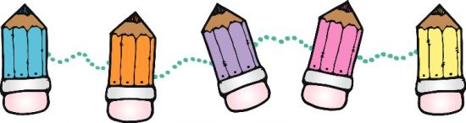 

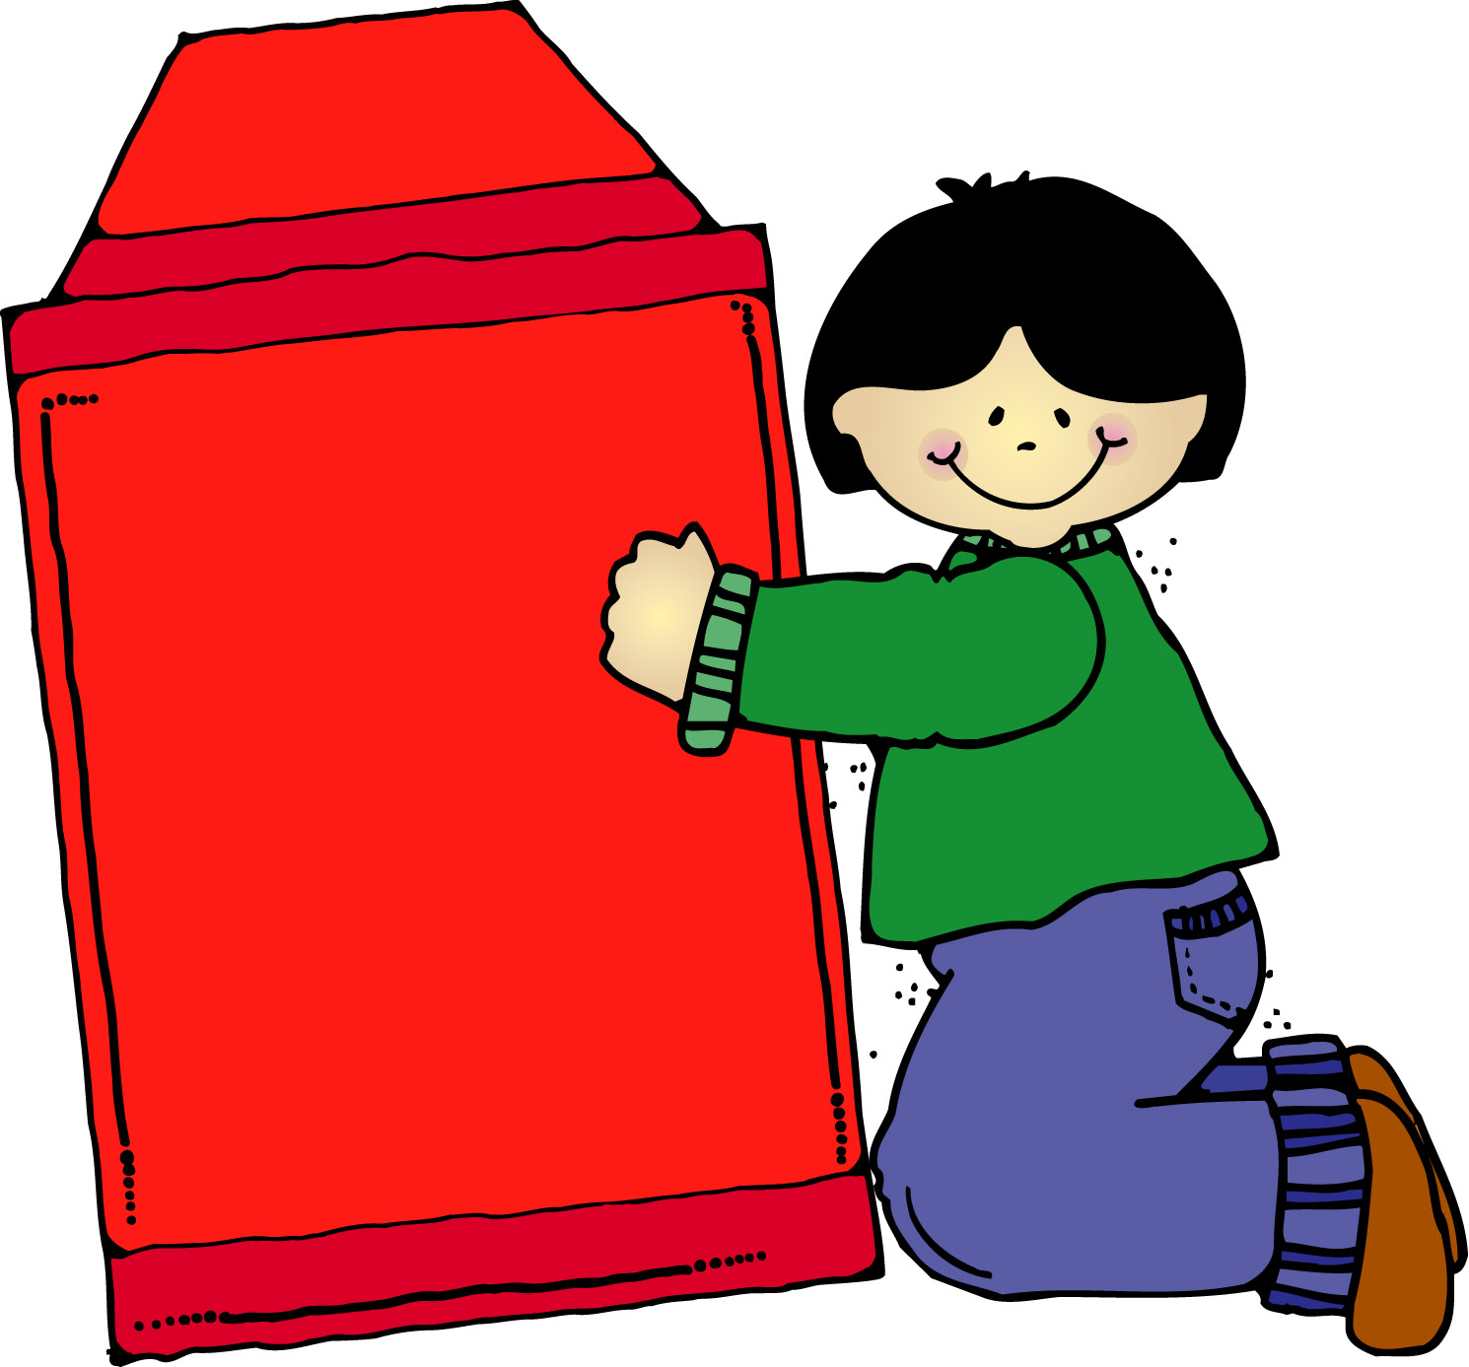

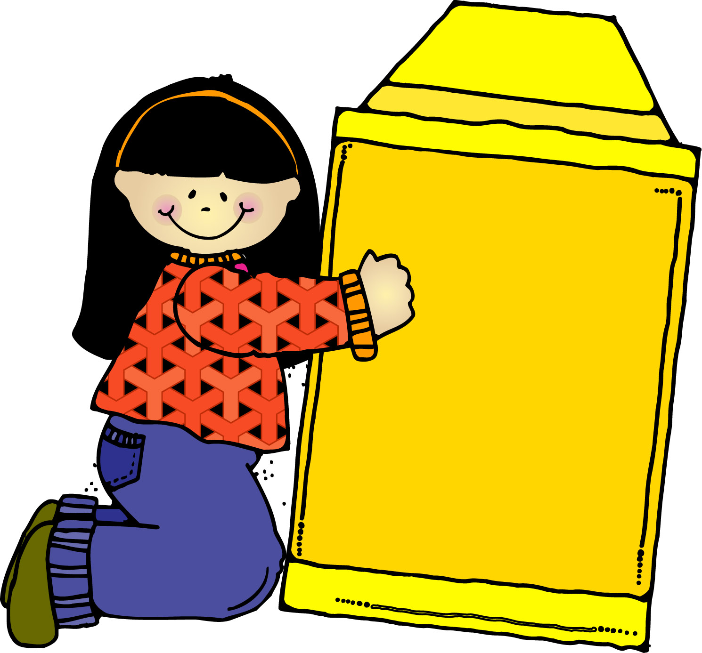

**Mrs. Fowler Contact Information:**

**Classdojo**  **Email Address**: [fowlesh3@boe.richmond.k12.ga.us](mailto:fowlesh3@boe.richmond.k12.ga.us) **Phone:** (706)796-4985

**Mrs. Fowler Contact Information:**

**Classdojo**  **Email Address**: [fowlesh3@boe.richmond.k12.ga.us](mailto:fowlesh3@boe.richmond.k12.ga.us) **Phone:** (706)796-4985

**Instructional Philosophy**

Each 4th grade classroom will demonstrate an environment full of rigor and relevance. Individualized instruction will be used to support students with different learning styles and learning modalities. This will be done through the use of videos, PowerPoints, paired activities, individualized assignments, and various hands on activities. Each classroom will include the use of [technology](http://712educators.about.com/cs/technology/a/integratetech.htm) and individual guided instruction to provide an environment where children will use self-discovery and a hands-on approach to learning.

**Homework Policy**

**Your child will have homework Monday – Thursday. All parts of the homework should be completed and returned the following school day. Parental guidance is greatly appreciated. Parents we will discuss as a team how we will implement behavior conduct in the next few weeks as we are reviewing rituals and routines.**

**Supplies and Materials**

**Backpack (label)**

**2 packs of #2 pencils (NO MECHANICAL PENCILS)**

**1 pair headphones (label)**

**2 packs of glue sticks**

**1 colored pencils (12-24 pack)**

**1 pack of big erasers**

**1 plastic GREEN pocket folder with prongs (Communication folder)**

**1 pencil pouch (no crayon box)**

**3 black composition notebooks**

**Wish List Items: lysol wipes, kleenex, hand sanitizer, ziploc bags (quart or gallon size), individually wrapped snacks/treats**

**1st Offense: Verbal Warning**

**2nd Offense: Reflection Time**

**3rd Offense: Parental Contact**

**4th Offense: Office Referral**

**Bee Kind**

**Bee Responsible**

**Bee Respectful**

**Bee Safe**

**Grading Policy**

**Richmond County School System will use the following numerical Grading System for grades 4-5th for the**

**2024-25 school year:**

**Academic Grading Scale**

**A** Represents an average of 90-100

**B** Represents an average of 80-89

**C** Represents an average of 75-79

**D** Represents an average of 70-74

**F** Represents an average of below 70

**Classroom Expectations**

* School begins at 7:00 a.m. Report on time, be prepared and ready to learn.
* Students are expected to follow school and

classroom rules at all times.

* Students are expected to remain on task

throughout the school day.

**Parents, the 4th grade team will be using the school wide behavior plan.**

**Home of the BEES Consequences**

**Course Assessment Plan** Each instructional domain will consist of pre and post assessments, lesson reviews, pop-quizzes and unit tests.

**Course Projects**

Projects will be announced as the year unfolds in a timely manner with deadlines and due dates.

**Course Goals**

**Course Goals**

At the end of fourth grade, the students will be able to read with understanding texts and to write on a variety of

genres. They will be able to fully understand and reason mathematically using a variety of skills and concepts. As for Social Studies and Science they will be able to master the concepts that were taught.